Oil and Gas — AlphaSense
Prompt B Output | 10 March 2026
Question
You are a senior energy sector analyst. Use AlphaSense to extract investment-grade intelligence on the global oil and gas market from earnings calls, broker research, expert transcripts, and regulatory filings. This is for an internal educational overview — not a buy/sell decision. Focus on primary source intelligence from the last 18 months. Cover the following: 1. MAJOR IOC EARNINGS INTELLIGENCE - What are BP, Shell, TotalEnergies, ExxonMobil, and Chevron saying about: - Production volumes and trajectory - Capital allocation: upstream vs downstream vs buybacks - Cost of production trends - Refining margins and downstream performance - Are their statements consistent with each other, or are there divergences worth noting? 2. ARAMCO AND NOC DISCLOSURES - What has Saudi Aramco disclosed in recent filings about: - Spare production capacity - Cost of production - Capital expenditure plans - Dividend sustainability - What do broker notes say about Aramco's true production capacity vs stated capacity? 3. SHALE PRODUCERS - What are the major US shale operators (Pioneer, Devon, EOG, Diamondback, Occidental) saying about: - Production costs per barrel (current) - Breakeven price levels - Capital discipline vs growth - Hedging positions 4. COMMODITY TRADERS - Any broker or expert intelligence on Vitol, Trafigura, Gunvor, or Glencore's oil trading operations - Scale of physical oil volumes traded - Profitability in current market conditions 5. SANCTIONS AND GEOPOLITICS - What do expert calls and broker research say about: - Iran's actual production and export volumes under sanctions - Russia's rerouting of exports and the effectiveness of price cap enforcement - Market impact of the current Iran conflict (March 2026) 6. SUPPLY AND DEMAND OUTLOOK - What is the broker consensus on: - Global oil demand growth for 2025–2026 - OPEC+ compliance and spare capacity - US shale production growth trajectory - Inventory levels vs historical averages OUTPUT FORMAT: - Section-by-section findings - Source each claim: company name, document type, date - Distinguish confirmed facts from analyst consensus from emerging signals - Flag where evidence is thin, conflicting, or based on single sources - Note any significant divergence between what companies say publicly and what analysts believe
View in Gen Search
Answer
Global Oil & Gas Market Deep-Dive: IOC Consolidation, NOC Capacity, Shale Discipline, and Geopolitical Supply Shocks (2024-2026)
Key Takeaways
- US Majors Face Earnings Decay Despite Volume Records : ExxonMobil and Chevron set operational production records but saw adjusted EPS decline for the third consecutive year , with Freedom Broker maintaining "Sell" ratings due to expected pressure from OPEC+ quota increases into 2026.
- European IOCs Slash Shareholder Returns Amid Balance Sheet Stress : BP entirely suspended share buybacks to reduce net debt to $14-18 billion by 2027 , while TotalEnergies halved its buyback program from $1.5 billion to $750 million due to weaker oil prices.
- Aramco's Spare Capacity Provides Unmatched Market Flexibility : Saudi Aramco maintains 12 million bpd Maximum Sustainable Capacity with approximately 2 million bpd readily available spare capacity, translating to $10-11 billion in incremental annual operating cash flow per 1 million bpd utilized.
- US Shale Pivots from Growth to Maintenance Amid Tier-One Depletion : Major operators institutionalized cash-return business models prioritizing maintenance-level production, with Diamondback openly acknowledging that the best Permian resources are being consumed , forcing exploratory capital into secondary zones like Barnett and Woodford shales.
- Russia's Shadow Fleet Faces Escalating Western Interdiction : The EU's 19th sanctions package targeted shadow fleet registries and vessels, with Denmark and Germany physically intercepting aging tankers using environmental regulations, while the US seized a Russian-flagged oil tanker in the North Atlantic , signaling aggressive enforcement.
- Middle East Crisis Creates Severe Physical Supply Shock : Iran's closure of the Strait of Hormuz—handling 20% of global seaborne crude —forced Gulf producers to shut in wells, with Iraq slashing southern oilfield production by 70% (removing 1.3 mbd) and Qatar halting LNG production following drone strikes.
- Structural Oversupply Drives Inventory Builds Above Historical Norms : The global oil market faces a massive supply surplus of approximately 3.84 mbd in 2026 , with OECD commercial stocks reaching 2.84 billion barrels at end-2025—the first time exceeding the five-year average since February 2021.
Major IOC Earnings Intelligence
Production Volumes and Trajectory
Throughout the past 18 months, the major Integrated Oil Companies (IOCs) have presented a stark divergence in production trajectories, with US majors heavily out-scaling European counterparts through aggressive consolidation.
- ExxonMobil: The company achieved its highest production in over 40 years, averaging 4.7 million oil-equivalent barrels per day (boe/d) in 2025. ^{[1]} This was primarily driven by record output from the Permian Basin—bolstered by the Pioneer acquisition—and the start-up of the Prosperity FPSO in Guyana. ^{[2]} Management expects the proportion of production from the Americas to continue growing over the next several years. ^{[3]}1 2 3 • 10K
- Chevron: Chevron similarly reported record annual worldwide and US net oil-equivalent production for 2025. ^{[5]} The recent acquisition of Hess Corporation contributed 261,000 boe/d, while legacy operations added 124,000 boe/d. ^{[6]} The company reached 1 million boe/d in the Permian and expects Gulf of Mexico production to hit 300,000 boe/d in 2026. ^{[4]}5 6 • INTRM 4 • Transcript - Earnings Calls
- TotalEnergies: The company achieved a 4% year-over-year increase in hydrocarbon production in 2025. ^{[7]} New projects added 150,000 boe/d, which offset a portfolio base decline rate of around 4% per year. ^{[8]}7 8 • Transcript - Earnings Calls
- Shell: Production saw modest growth, rising 2.7% year-over-year in the fourth quarter of 2025 to 2.84 million boe/d. ^{[9]} This increase came from the ramp-up of new projects in the Gulf of Mexico and Brazil, which successfully offset the divestment of its onshore Nigerian subsidiary (SPDC). ^{[10]}9 10 • Freedom Broker
- BP: In contrast to its peers, BP's underlying production remained broadly flat in 2025 compared to 2024. ^{[11]} The company expects underlying upstream production to remain broadly flat again in 2026, with oil production flat and gas production trending slightly lower. ^{[12]}11 • ARS 12 • ARS
Capital Allocation: Upstream vs Downstream vs Buybacks
A significant divergence has emerged between how US and European majors are allocating capital amidst softening macroeconomic conditions. While ExxonMobil and Chevron remain resolute on shareholder returns, BP and TotalEnergies have sharply altered their distribution frameworks.
- BP: In a major shift, BP's board decided to entirely suspend its share buyback program to allocate excess cash toward strengthening its balance sheet. ^{[13]} The company is targeting a reduction in net debt to a range of $14 billion to $18 billion by the end of 2027. ^{[15]} BP also reduced its 2026 capital expenditure budget to the lower end of its guidance, aiming for $13 billion to $13.5 billion. ^{[14]}13 15 • ARS 14 • INTRM
- TotalEnergies: The French major announced a substantial reduction in share repurchases, halving its buyback program from $1.5 billion in Q4 2025 to $750 million for Q1 2026 due to weaker oil prices. ^{[16]} The company also revised its capital expenditure downward from $16 billion to $15 billion. ^{[17]}16 • Freedom Broker 17 • Transcript - Earnings Calls
- Shell: Shell diverged from its European peers by maintaining its distribution framework, calling its target of returning 40% to 50% of cash flow from operations (CFFO) "sacrosanct." ^{[18]} The company announced a 4% dividend increase and a fresh $3.5 billion share buyback program for Q1 2026. ^{[19]} Cash capex for 2026 is maintained at $20 billion to $22 billion. ^{[20]}18 19 20 • Transcript - Earnings Calls
- ExxonMobil: ExxonMobil continues to invest heavily, projecting $27 billion to $29 billion in cash capital expenditures for 2026. ^{[21]} The company noted it has distributed $150 billion to shareholders over the past five years and intends to continue consistent repurchases and dividend growth. ^{[23]} ^{[22]}21 • 8K 22 • Transcript - Earnings Calls

18 Feb • Annual Report FY 2025
ExxonMobil FY 2025 financial summary detailing earnings and cash capital expenditures by segment
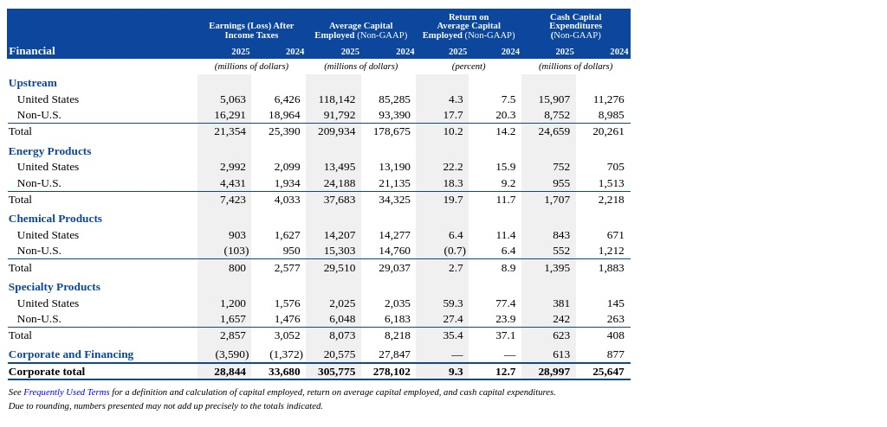

- Chevron: Following its Hess integration, Chevron announced a 4% increase in its quarterly dividend and repurchased $3 billion in shares during Q4 2025. ^{[25]}25 • Transcript - Earnings Calls
Cost of Production Trends
All majors publicly report aggressive structural cost reductions, leveraging technological integration and operational efficiency to push breakevens lower.
- ExxonMobil: The company reports cumulative structural cost savings of $15.1 billion since 2019 and expects to reach $20 billion by 2030. ^{[27]} Management claims plans are firm to improve corporate breakevens to $35 per barrel by 2027 and $30 per barrel by 2030. ^{[26]}27 • 8K 26 • Transcript - Earnings Calls
- Chevron: Following the implementation of a new operating model, Chevron captured approximately $1.5 billion in annual run-rate structural cost savings. ^{[28]}28 • Transcript - Earnings Calls
- TotalEnergies: The company continues to boast a highly competitive cost structure, maintaining its upstream production costs at $5 per barrel of oil equivalent. ^{[29]}29 • Transcript - Earnings Calls
- BP: BP increased its group structural cost reduction target to $5.5 billion to $6.5 billion by the end of 2027. ^{[30]} Operationally, the company achieved record full-year upstream plant reliability of 96.1%. ^{[31]}30 31 • ARS
Refining Margins and Downstream Performance
Downstream performance has been highly volatile, with periods of severe margin compression followed by acute margin expansion due to geopolitical supply disruptions and shifting crude feed costs.
- ExxonMobil: Late 2025 saw a massive recovery in refining profitability for ExxonMobil; Energy Products earnings surged eight-fold year-over-year to $2.9 billion in Q4 2025. ^{[33]} Management attributed improved refining margins to a looser crude market providing cheaper feedstock, coupled with product supply tightness driven by global capacity disruptions. ^{[32]}33 • Freedom Broker 32 • Transcript - Earnings Calls
- Chevron: The company delivered its highest US refinery throughput in two decades during 2025, driven by recent expansion projects and high operational efficiency. ^{[34]}34 • Transcript - Earnings Calls
- Shell: Shell's fourth-quarter 2025 products division posted strong results buoyed by higher refining margins, but this was offset by persistent low margins and weak operational performance in its Chemicals unit. ^{[35]} Fixing the Chemicals business is cited as a key strategic priority for 2026. ^{[36]}35 36 • Transcript - Earnings Calls
- BP: Despite recording its highest ever full-year refining availability at 96.3%, BP continues to forecast that realized refining margins will remain low heading into 2026. ^{[37]}37 • ARS
Analyst Consensus, Divergences, and Emerging Signals
While company executives emphasize record volumes and strategic resilience, the analyst community flags underlying weaknesses regarding earnings decay and reserve lifespans.
Freedom Broker highlights a structural divergence between what US majors are reporting in volume and what they are delivering to the bottom line. ^{[38]} Despite ExxonMobil and Chevron setting operational production records, both companies have seen their adjusted EPS decline for the third consecutive year. ^{[39]} Freedom Broker views both US equities as trading above fundamental value, maintaining "Sell" ratings on ExxonMobil and Chevron due to expected pressure from OPEC+ quota increases into 2026. ^{[40]} Furthermore, Freedom Broker downgraded both BP and TotalEnergies to "Sell," noting that their decisions to suspend or halve buybacks, while financially prudent, signal deteriorating market fundamentals and reflect recent, unjustified stock rallies. ^{[41]}38 • Freedom Broker 39 40 • Freedom Broker 41 • Freedom Broker
Edison Investment Research views BP's recent strategic shifts as a necessary correction. ^{[42]} The firm notes that BP's decision to pivot back toward core oil and gas operations and suspend share buybacks is the required medicine to fix a balance sheet that has a greater debt weighting compared to peers. ^{[43]}42 43 • Edison Investment Research
Hannam & Partners identifies a critical emerging signal regarding long-term upstream viability: the major IOCs are struggling with organic resource replenishment. ^{[44]} The firm notes that the industry loses roughly 5% of supply annually to natural decline, but most majors posted organic reserve replacement ratios below 100% in 2025. ^{[45]} This systemic shortfall is forcing exploration back to center stage and driving the aggressive M&A appetite currently observed across the sector. ^{[46]}44 45 46 • Hannam & Partners
Aramco and NOC Disclosures
Spare Production Capacity and True vs. Stated Limits
Saudi Aramco maintains a publicly stated Maximum Sustainable Capacity (MSC) of 12.0 million barrels per day (bpd) of crude oil. ^{[47]} Under current OPEC+ quotas and production levels, management reports that the company holds approximately 2 million bpd of readily available spare capacity. ^{[48]} This massive operational buffer provides unmatched flexibility to capture demand upside with minimal to no additional capital deployment. ^{[49]}47 • Transcript - Earnings Calls 48 • Transcript - Earnings Calls 49 • Transcript - Earnings Calls
Regarding the financial impact of this buffer, Aramco provides a direct rule of thumb: every 1 million bpd of spare capacity utilized translates to roughly $10 billion to $11 billion in incremental annual operating cash flow, based on 2025 average Brent crude prices. ^{[50]}50 • Transcript - Earnings Calls
While the investment community historically debated the validity of Aramco's "true" production capacity versus its officially stated numbers, current broker research shows no significant divergence from company claims. Analysts widely accept the official 12 million bpd MSC limit. Oxford Business Group notes that Aramco's estimated spare capacity actually represents roughly 2.9% of total global daily oil demand, confirming the company's stated capacity figures as a foundational macro-economic anchor. ^{[51]}51 • Oxford Business Group
Cost of Production
Aramco continues to report the lowest structural cost profile among major global integrated producers. ^{[52]} For the full year 2025, the company's average upstream lifting costs were recorded at just $3.51 per barrel of oil equivalent (boe). ^{[53]} Furthermore, upstream capital expenditures averaged only $8.00 per boe produced during the same period. ^{[54]}52 • Earnings Presentation 53 54 • ARS
Management attributes these extreme structural cost advantages to several localized factors. These include a low-depletion-rate operational model, the highly favorable geology of Saudi Arabia's onshore and shallow-water offshore reservoirs, and massive synergies generated by the company's centralized infrastructure and logistics networks. ^{[55]} Additionally, this low-cost operational framework directly contributes to Aramco having one of the lowest upstream carbon intensities in the industry. ^{[56]}55 56 • ARS
Capital Expenditure Plans and Strategic Gas Pivot
Aramco's total capital investment for 2025 was $52.2 billion, which landed precisely in line with its prior guidance. ^{[57]} Looking forward, the company has established a 2026 capital investment guidance range of $50.0 billion to $55.0 billion. ^{[58]} In the short term, this capital allocation is split roughly 60% for Upstream, 30% for Downstream, and 10% for New Energies. ^{[59]}57 58 • ARS 59 • Transcript - Earnings Calls
A significant portion of Aramco's capital pipeline is being redirected toward a massive expansion in natural gas. The company recently increased its 2030 target for sales gas production capacity growth to approximately 80% over 2021 levels, up from a previous target of 60%. ^{[60]} This accelerated gas expansion program is expected to yield around 6 million boe per day by 2030. ^{[61]} A critical milestone in this strategy was achieved in December 2025, when production officially began at the massive Jafurah unconventional gas basin. ^{[62]}60 • ARS 61 • Transcript - Earnings Calls 62 • ARS
Dividend Sustainability and Balance Sheet Strength
Despite crude price volatility, Aramco's dividend framework remains highly robust, anchored by an unmatched balance sheet. The company generated $85.4 billion in free cash flow in 2025. ^{[63]} This easily funded total shareholder distributions of $85.5 billion over the year. ^{[64]}63 64 • ARS
The company declared a Q4 2025 base dividend of $21.89 billion, representing a 3.5% year-over-year increase and marking the fourth consecutive year of base dividend growth. ^{[65]} In addition to this progressive base, Aramco employs a performance-linked dividend mechanism designed to distribute 50% to 70% of combined full-year free cash flow. ^{[66]} To further return capital, the Board announced a new share buyback program of up to $3.0 billion to be executed over 18 months. ^{[67]}65 67 • ARS 66 • PROSP
Dividend sustainability is guaranteed by Aramco's extremely conservative leverage profile. The company's gearing ratio actually fell to 3.8% at the end of 2025, down from 4.5% at the end of 2024, providing the lowest gearing and highest cash availability among its IOC peers. ^{[68]}68 • ARS
Analyst Consensus and Emerging Signals
Broker sentiment strongly aligns with Aramco's stated financial and operational metrics, though analysts place specific emphasis on the macroeconomic ramifications of the company's natural gas pivot.
- QNB Financial Services focuses heavily on the broader economic implications of the Jafurah gas project, framing it as a "$100 billion bet" to replace domestic crude consumption. ^{[69]} The broker points out that Saudi Arabia historically burns massive volumes of crude oil for power generation. ^{[70]} By successfully replacing this with natural gas by 2030, Aramco aims to free up roughly 500,000 bpd of crude oil for international export, which could generate nearly $12.8 billion in additional annual revenue for the Kingdom at current prices. ^{[71]}69 70 71 • QNB Financial Services
- FAB Securities views Aramco's operational framework as a powerful defensive asset. ^{[72]} The firm maintains an 'A+' standalone credit rating outlook for the company, noting that Aramco's extraordinarily low production costs and vast reserves serve as a highly effective offset against long-term energy transition risks. ^{[73]}72 73 • FAB Securities
- SP Angel emphasizes the sheer cash-generating power of the business model, noting that the $85.4 billion free cash flow efficiently supports both the heavy $52.2 billion CapEx burden and an attractive ~5% annualized dividend yield, ending the year with a highly manageable net debt of only $18.3 billion. ^{[74]}74 • SP Angel
Shale Producers
Capital Discipline vs. Growth: The Industry Consensus
The era of aggressive, debt-fueled production growth in the US shale patch has definitively ended. Across the board, major operators have institutionalized a cash-return business model that prioritizes maintenance-level production, relentless cost-cutting, and aggressive shareholder distributions.
Operators recognize that the prime tier of US shale is maturing, forcing a pivot toward operational excellence and secondary zone development. Diamondback Energy explicitly notes that as the US shale industry matures and the best resources are consumed, maintaining an advantage in inventory quality and duration is an existential imperative. ^{[75]} Reflecting this macro reality, executives across these firms consistently report that any potential production growth is a secondary output of capital efficiency, rather than a primary operational target. ^{[76]}75 • 8K 76 • Transcript - Earnings Calls
Diamondback Energy
- Production Costs: Diamondback reported an average lease operating expense (LOE) of $5.55 per barrel of oil equivalent (boe) for the full year 2025. ^{[77]} Total cash operating expenses averaged $10.23 per boe. ^{[79]} The company successfully drove its well costs per lateral foot down to 2020 COVID-era lows through extended lateral lengths and continuous pumping techniques. ^{[78]}77 79 • INTRM 78 • 8K
- Breakeven Levels: Management evaluates its base dividend breakeven against a $40 per barrel WTI crude scenario. ^{[80]}80 • Transcript - Earnings Calls
- Capital Discipline: Operating with a highly efficient 39% reinvestment ratio, Diamondback generated $5.9 billion in adjusted free cash flow in 2025. ^{[81]} For 2026, the company is enforcing strict capital discipline, planning to keep activity and production completely flat at 500,000 to 510,000 barrels of oil per day (bbl/d). ^{[82]}81 82 • 8K
- Hedging Position: The company aggressively hedges to protect cash flow, utilizing a mix of swaps, basis swaps, roll swaps, and costless collars. ^{[83]} As of late 2025, Diamondback held a net asset derivative position of $90 million related to commodity price risk. ^{[84]}83 84 • 10Q
Devon Energy
- Production Costs & Breakeven: Devon's highly efficient capital program is fully funded—including its base dividend—at WTI prices below $45 per barrel. ^{[85]} Management frequently highlights an ultra-low operating breakeven of around $40 per barrel. ^{[86]}85 • Transcript - Earnings Calls 86 • Transcript - Earnings Calls
- Capital Discipline: Devon plans to reduce its 2026 capital budget by $500 million compared to 2025 maintenance levels, targeting a spend of $3.5 billion to $3.7 billion. ^{[88]} ^{[87]} The company intends to hold production perfectly steady at approximately 845,000 boe/d, noting that they "do not plan to add incremental barrels to the market at this time" due to macroeconomic uncertainty. ^{[89]}88 89 • Transcript - Earnings Calls

18 Feb • MDA
Devon Energy operating cash flow, capital expenditures, and net earnings (2023-2025)
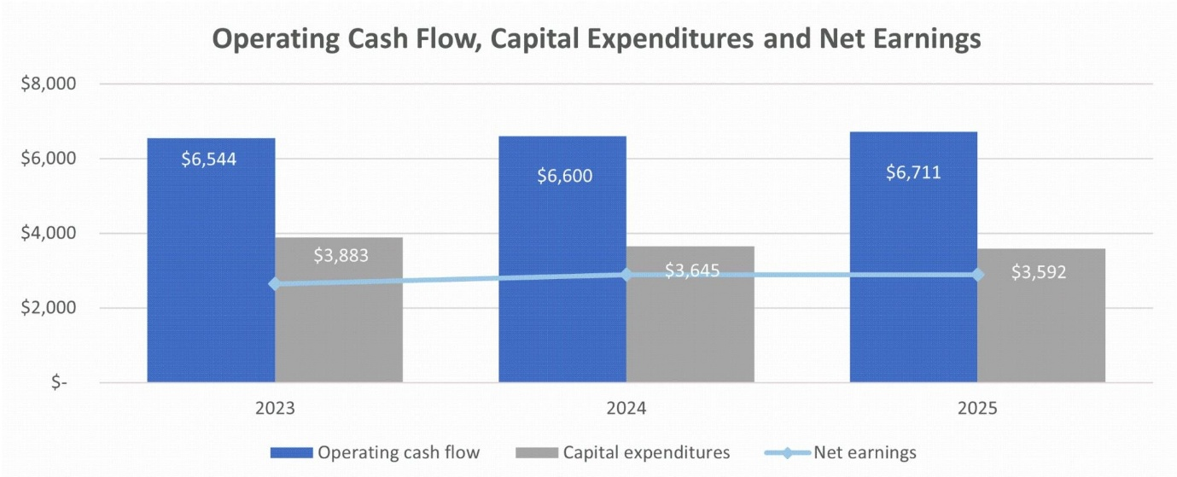

- Hedging Position: To insulate cash flows, Devon relies on financial price swaps, basis swaps, and costless price collars. ^{[92]} The company currently has approximately 30% of its anticipated 2026 oil and gas production hedged. ^{[91]}92 • 10Q 91 • ARS
EOG Resources
- Production Costs & Breakeven: EOG has reduced its average well costs by 7% across its multi-basin portfolio in 2025, contributing to a total well cost reduction of more than 15% over the past two years. ^{[94]} The company enforces a stringent premium hurdle rate, requiring all direct well investments to earn at least a 30% direct after-tax return assuming flat $40 per barrel oil and $2.50 per Mcf natural gas prices. ^{[93]}94 • Press Release 93 • Transcript - Earnings Calls
- Capital Discipline: EOG explicitly avoids falling into a "manufacturing mode" of stamping out uniform well designs, instead focusing on continuous, iterative improvements per well. ^{[95]} EOG's production growth is intentionally constrained; management referred to its recent 10,000 bbl/d growth rate as "pretty soft," signaling that they are purposefully choosing free cash flow generation over volume maximization. ^{[96]}95 • Transcript - Earnings Calls 96 • Transcript - Earnings Calls
- Hedging Position: EOG engages in price risk management using price swaps, options, swaptions, and collars. ^{[97]} The company elects not to designate these contracts as accounting hedges, instead utilizing a mark-to-market accounting method. ^{[98]}97 98 • 10Q
Occidental Petroleum
- Production Costs: In the fourth quarter of 2025, Occidental achieved its lowest quarterly domestic lease operating expense since 2021, dropping to $7.77 per boe.
- Breakeven & Capital Discipline: For 2026, Occidental is targeting a flexible $55 to $60 WTI capital plan. ^{[100]} The company is slashing its 2026 capital spend by $550 million to a range of $5.5 billion to $5.9 billion, while still expecting to deliver 1% production growth. ^{[99]} Occidental is increasingly redirecting capital toward mid-cycle secondary recovery, adding $200 million for Gulf of Mexico waterfloods and Permian enhanced oil recovery (EOR) to lower its overall base decline rate. ^{[101]}100 • Transcript - Earnings Calls 99 101 • Transcript - Earnings Calls
- Hedging Position: Historically, Occidental's practice has been to remain exposed to the market prices of commodities, utilizing short-duration physical and financial forward marketing contracts rather than structural long-term hedges. ^{[102]} As of late 2024, the company maintained no active commodity hedges. ^{[103]}102 103 • 10K
Pioneer Natural Resources (Acquired by ExxonMobil)
- Context: Pioneer Natural Resources ceased operating as an independent entity when it was acquired by ExxonMobil on May 3, 2024, in an all-stock transaction valued at $63 billion. ^{[104]}104 • 10K
- Costs & Discipline: Prior to the merger, Pioneer operated with a peer-leading framework that returned 75% of free cash flow to shareholders. ^{[105]} Post-acquisition, ExxonMobil expects to leverage Pioneer's massive contiguous acreage blocks to deploy proprietary cube development designs, driving industry-leading capital efficiency. ^{[106]} ExxonMobil projects this integration will allow it to roughly double Permian Basin production to 2.3 million boe/d by 2030. ^{[107]}105 • Transcript - Earnings Calls 106 107 • 10K
Analyst Consensus and Emerging Signals
- Streetwise Reports flags a critical divergence in the Permian Basin's current maturity phase. The broker notes that while "headline giants" like ExxonMobil and Chevron have acquired massive scale at premium prices, the true hidden gems are the more subdued, elite operators capable of maintaining output while actively spending less per barrel to accomplish it. ^{[108]} The firm argues that sustaining output demands constant reinvestment due to rapid shale decline rates, meaning the market investment opportunity has shifted entirely from "Permian growth to Permian maintenance." ^{[109]}108 109 • Streetwise Reports
- Freedom Broker views EOG Resources favorably due to its aggressive footprint expansion. The broker maintains a "Buy" rating on EOG, noting that the company's recent $5.6 billion acquisition in the Utica Shale expanded its total footprint in the formation to 1.1 million acres, elevating undeveloped reserves to over two billion barrels of oil equivalent and positioning the company to capture up to $150 million in first-year synergies. ^{[110]}110 • Freedom Broker
- Emerging Signal (Resource Exhaustion): There is mounting, explicit evidence from operators that tier-one inventory exhaustion is actively altering capital allocation. Diamondback openly acknowledges that the best resources in the Permian are being consumed. ^{[111]} As a direct response to this degradation, operators are being forced to allocate meaningful exploratory capital to secondary and deeper zones—such as the Barnett and Woodford shales—to organically extend their inventory lifespans. ^{[112]}111 112 • 8K
Commodity Traders
Scale of Physical Oil Volumes and Profitability
Note on Evidence: While specific, aggregated real-time barrels per day (bpd) volumes and net profitability figures for private trading houses (Vitol, Trafigura, Gunvor) are largely shielded from public broker research, expert transcripts provide foundational baselines for their operational scale and margin structures.
- Margin Structure: A former industry competitor notes that the core wholesale trading business for major houses typically operates on razor-thin margins of 3% to 5% in normalized years. ^{[113]} Because buyers and sellers are massive global entities, traders lack immense pricing power, making the business model entirely dependent on executing massive volumes to generate billion-dollar quarterly profits. ^{[114]}113 114 • Expert Call
- Glencore's Scale: Glencore is estimated to trade approximately 6 million barrels of crude oil per day. ^{[115]} Historically, more than 50% of the company's revenue has been generated from oil trading. ^{[116]}115 116 • Expert Call
- Glencore's Profitability: Freedom Broker reports that Glencore's trading arm demonstrated resilience despite cooling global energy markets, with the company expecting its FY2025 Marketing Adjusted EBIT to land at the mid-point of its $2.3 billion to $3.5 billion guidance range. ^{[117]} Record contributions from metals and minerals helped offset weakness in the energy division, driving total company Adjusted EBITDA to $13.5 billion for the year. ^{[118]}117 • Freedom Broker 118 • Freedom Broker
- Consensus on Glencore Trading: Vunani Securities echoes this outlook, confirming Glencore's expectation of $2.3 billion to $3.5 billion in marketing adjusted EBIT for FY25. ^{[119]}119 • Vunani Securities
Vitol and Trafigura: Geopolitical Arbitrage and Expansion
Major traders are actively navigating shifting geopolitical sanctions to capture lucrative arbitrage opportunities, particularly regarding Venezuelan crude.
SMIFS reports that both Vitol Group and Trafigura Group successfully obtained preliminary US Treasury licenses to export and market millions of barrels of Venezuelan oil. ^{[120]} Representatives from both firms were invited to the White House to discuss the reintegration of Venezuelan crude into global markets, highlighting their critical role as intermediaries in sanctioned environments. ^{[121]}120 121 • SMIFS
Systematix Institutional Research indicates that Vitol is deepening its structural ties in Asia, preparing to launch a Singapore-based trading joint venture with Indian Oil Corporation to trade crude and fuels over an initial 5 to 7 year period. ^{[122]}122 • Systematix Institutional Research
Shajar Capital notes that Vitol has also expanded its footprint in South Asia by supplying 1 million barrels of US West Texas Intermediate (WTI) crude to Pakistan's Cnergyico, marking the country's first-ever purchase of US crude under a new term agreement. ^{[123]}123 • Shajar Capital
Gunvor: Sanctions Fallout and Restructuring
Gunvor has faced severe operational headwinds due to US geopolitical maneuvering and allegations regarding its ties to Russia.
SP Angel highlights that Gunvor was forced to withdraw its bid to acquire Lukoil's international assets. ^{[124]} The collapse of the deal occurred after the US Treasury explicitly opposed the acquisition, labeling the Swiss-based trader a "Kremlin puppet" and threatening to withhold operational licenses. ^{[125]}124 125 • SP Angel
SMIFS notes that this intense regulatory scrutiny led to a dramatic restructuring at the top of the firm, with 72-year-old founder Torbjörn Törnqvist abruptly departing the company. ^{[126]} Törnqvist struck a deal to sell his 86% stake to a group of employees in a bid to contain the fallout from the US Treasury's allegations and preserve the firm's global trading capabilities. ^{[127]}126 127 • SMIFS
Ubhar Capital reports that, in an effort to smooth over ties with Washington following the Lukoil fallout, Gunvor is now actively weighing investments into US oil- and gas-producing assets. ^{[128]}128 • Ubhar Capital
Sanctions and Geopolitics
Iran's Production and Export Volumes Under Sanctions
Prior to the outbreak of direct military hostilities in late February 2026, Iran had successfully navigated Western sanctions to maintain a robust baseline of production and export activity.
WIIW estimates that despite tight sanctions and a lack of upstream investment over the past decade, Iran maintained a production capacity of roughly 3.2 to 3.6 million barrels per day (mbd). ^{[129]} Out of this capacity, approximately 2.0 mbd were actively exported to global markets. ^{[130]}129 130 • WIIW
Commerzbank reports slightly more conservative export figures, noting that Iranian crude oil exports stood at 1.6 mbd in January 2026, having fallen from a peak of 1.8 to 1.9 mbd in autumn 2025. ^{[131]}131 • Commerzbank
WIIW confirms that the vast majority of these exports were directed to China and India, facilitated through camouflage techniques, ship-to-ship transfers in open seas, and the manipulation of transponder data by shadow fleets. ^{[132]} To compensate buyers for the legal and logistical risks of this sanction-evading trade, Iranian light crude was structurally underpriced, frequently offered at a discount of $8 to $10 per barrel below the Brent benchmark. ^{[133]}132 133 • WIIW
Russia: Export Rerouting and the Squeeze on the Shadow Fleet
Since the 2022 invasion of Ukraine, Russia has mirrored Iran's evasion tactics, though the effectiveness of these measures is currently facing unprecedented strain as Western enforcement hardens in early 2026.
Ambit Capital notes that Western price caps and embargoes largely failed to achieve their primary goal of reducing physical Russian export volumes. ^{[134]} By utilizing a massive shadow fleet and offering deep discounts of $10 to $15 per barrel, Russia successfully rerouted an average of 7.2 to 7.5 mbd of crude to price-sensitive refineries in India and China. ^{[135]}134 135 • Ambit Capital
However, CD Equisearch highlights an emerging signal that this logistical lifeline is rapidly fraying under the weight of operational attrition and aggressive Western intervention. ^{[136]} The European Union's 19th sanctions package specifically targeted the registries, brokers, and individual vessels enabling the shadow fleet. ^{[137]} Furthermore, European coastal states—particularly Denmark and Germany—have begun utilizing environmental safety regulations to physically intercept, inspect, and detain aging shadow vessels attempting to navigate key chokepoints like the Baltic Sea. ^{[138]}136 137 138 • CD Equisearch
Systematix Institutional Research provides evidence of this escalating enforcement, reporting that the US recently seized a Russian-flagged oil tanker in the North Atlantic. ^{[139]} This aggressive maneuver signals a definitive shift toward dismantling rapid reflagging strategies and directly punishing entities moving sanctioned crude. ^{[140]}139 140 • Systematix Institutional Research
Kiwoom Sekuritas adds that the G7 and the European Union are now actively discussing options to entirely replace the porous $60 price cap with a comprehensive ban on maritime services. ^{[141]} If implemented, this would prohibit Western entities from providing any shipping, insurance, financing, or brokerage services to Russian oil, threatening to paralyze Moscow's export capabilities. ^{[142]}141 142 • Kiwoom Sekuritas
Market Impact of the March 2026 Middle East Crisis
The joint US-Israeli military campaign against Iran ("Operation Epic Fury") launched in late February 2026 has transitioned geopolitical risk from a theoretical premium into a severe physical supply shock.
BIMB Securities reports that Iran retaliated by effectively closing the Strait of Hormuz, a critical maritime chokepoint that handles approximately 20% of the world's seaborne crude oil trade and a substantial share of global LNG exports. ^{[143]}143 • BIMB Securities
QNB Financial Services confirms the immediate, cascading impact of this blockade on regional production. ^{[144]} Because ships cannot safely transit the Strait, onshore storage capacities for crude and refined products rapidly exhausted, forcing major Gulf producers to physically shut in wells. ^{[145]} Iraq slashed production at its main southern oilfields by 70% (removing 1.3 mbd), while Kuwait, Bahrain, and the UAE curtailed output and declared force majeure on shipments. ^{[146]} Concurrently, Qatar completely halted LNG production at its Ras Laffan export hub following drone strikes. ^{[147]}144 146 147 • QNB Financial Services 145 • QNB Financial Services
ING Wholesale Banking notes that while Saudi Arabia and the UAE possess the infrastructure to divert up to 5 mbd of crude via pipeline to the Red Sea, roughly 15 mbd of global oil supply remains trapped behind the Strait of Hormuz. ^{[148]}148 • ING Wholesale Banking
Kiwoom Sekuritas tracks the extreme price action resulting from this bottleneck, noting that Brent crude briefly surged to nearly $120 per barrel in intraday trading—its highest level since 2022. ^{[149]} Prices only pulled back toward the $90 range after reports emerged that the G7 was preparing a coordinated release of strategic petroleum reserves and considering temporary waivers on Russian oil sanctions to inject emergency supply into the market. ^{[150]}149 150 • Kiwoom Sekuritas
Analyst Consensus, Divergences, and Emerging Signals
While the market acknowledges the severity of the Hormuz blockade, there is deep divergence among analysts regarding the longevity of the oil price spike.
An expert from Weatherford argues that prior to the conflict, the market had become dangerously complacent, fundamentally mispricing geopolitical risk into $60 oil. ^{[151]} The expert asserts that true structural risks justify a sustained floor of $80 or more per barrel, regardless of short-term resolutions. ^{[152]}151 152 • Expert Call
Kenanga Research aligns with this bullish, prolonged-risk outlook. ^{[153]} The firm warns that if the conflict expands and causes structural damage to Middle Eastern energy infrastructure, Brent crude prices could sustain significant upside for six months to several years. ^{[154]}153 154 • Kenanga Research
Desjardins Economics studies offers a contrasting, moderate view, pointing to underlying macroeconomic buffers. ^{[155]} The broker notes that heading into the conflict, the global oil market possessed a substantial 4.4 mbd surplus and ample unused OPEC+ capacity, providing a strong cushion that can readily replace Iranian supply once shipping lanes are secured. ^{[156]}155 157 • Desjardins Economics studies

Desjardins Economics studies • 4 Mar • ECONOMIC VIEWPOINT : Economic and Oil Market Implications
Comparison of Iran's crude production against expected market surplus and unused OPEC+ capacity
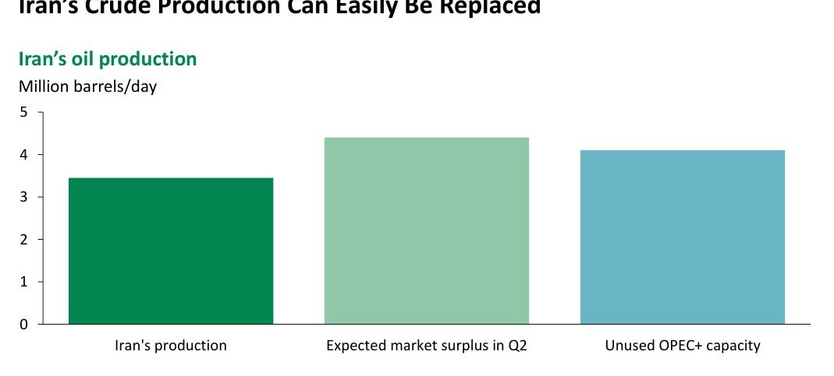

Zedcrest Wealth forcefully argues that the current price rally is a temporary panic rather than a structural shift. ^{[159]} The firm maintains that the underlying supply-demand dynamics for 2026 are fundamentally bearish, anchored by record US shale output and a systemic shift in Chinese consumption toward electric vehicles. ^{[160]} According to the broker, this long-term structural glut will reassert total control over pricing the moment acute geopolitical anxiety subsides. ^{[161]}159 160 161 • Zedcrest Wealth
Supply and Demand Outlook
Global Oil Demand Growth for 2025–2026
The broker consensus for 2025–2026 anticipates a deceleration in global oil demand growth, driven by a structural shift in consumption patterns across advanced economies and an overwhelming reliance on non-OECD markets.
- OPEC maintains the most bullish outlook among forecasters, projecting global oil demand to grow by a robust 1.4 million barrels per day (mb/d) in 2026 and 1.3 mb/d in 2027. ^{[162]} The broker attributes this nearly entirely to non-OECD nations, explicitly citing steady economic expansion in India, China, and the broader Asian region. ^{[163]}162 • OPEC 163 • OPEC
- Kamco notes that the International Energy Agency (IEA) takes a significantly more pessimistic stance, recently lowering its 2026 demand growth forecast to just 0.85 mb/d. ^{[164]} The broker highlights that this lowered forecast reflects persistent macroeconomic uncertainties and the expectation that petrochemical feedstocks will account for more than half of all demand gains, while traditional transportation fuel usage declines. ^{[165]}164 165 • Kamco
- ICBC International Research asserts that a peak in global oil demand is imminent, projecting consumption to increase by 1.1 mb/d in 2026, which remains notably below the pre-pandemic decade average of 1.5 mb/d. ^{[166]} The firm emphasizes that fuel demand for road transportation is facing severe downward pressure due to energy efficiency gains and accelerated electric vehicle penetration. ^{[167]}166 167 • ICBC International Research
- Meristem Securities confirms this structural drag, arguing that softer economic activity combined with rapid clean energy adoption in Europe and China will continue to restrain demand upside into 2026. ^{[168]}168 • Meristem Securities
The Structural Supply Surplus and Inventory Levels
Broker intelligence unequivocally agrees that the market is entering a period of severe structural oversupply, which is rapidly translating into physical inventory builds well above historical norms.
- MBC Group projects that the global oil market faces a massive supply surplus of approximately 3.84 mb/d in 2026. ^{[169]} The broker warns that this persistent imbalance will likely force commercial storage facilities on land to maximum capacity, pushing excess barrels into expensive floating storage and dragging Brent crude prices down toward an average of $55 per barrel. ^{[170]}169 170 • MBC Group
- U.S. Energy Information Administration (EIA) forecasts that global oil inventory builds will average a staggering 3.1 mb/d in 2026, compared to a 2.7 mb/d build in 2025, as global production fundamentally outpaces consumption. ^{[171]}171 • U.S. Energy Information Administration
- Commerzbank reports that this supply glut has completely erased previous market deficits, with commercial OECD stocks reaching 2.84 billion barrels at the end of 2025. The broker notes that this marks the first time since February 2021 that OECD inventories have exceeded the five-year average. ^{[172]}

Commerzbank • 3 Mar • Escalation in the Middle East drives up energy prices
OECD commercial oil inventories exceeding the five-year average
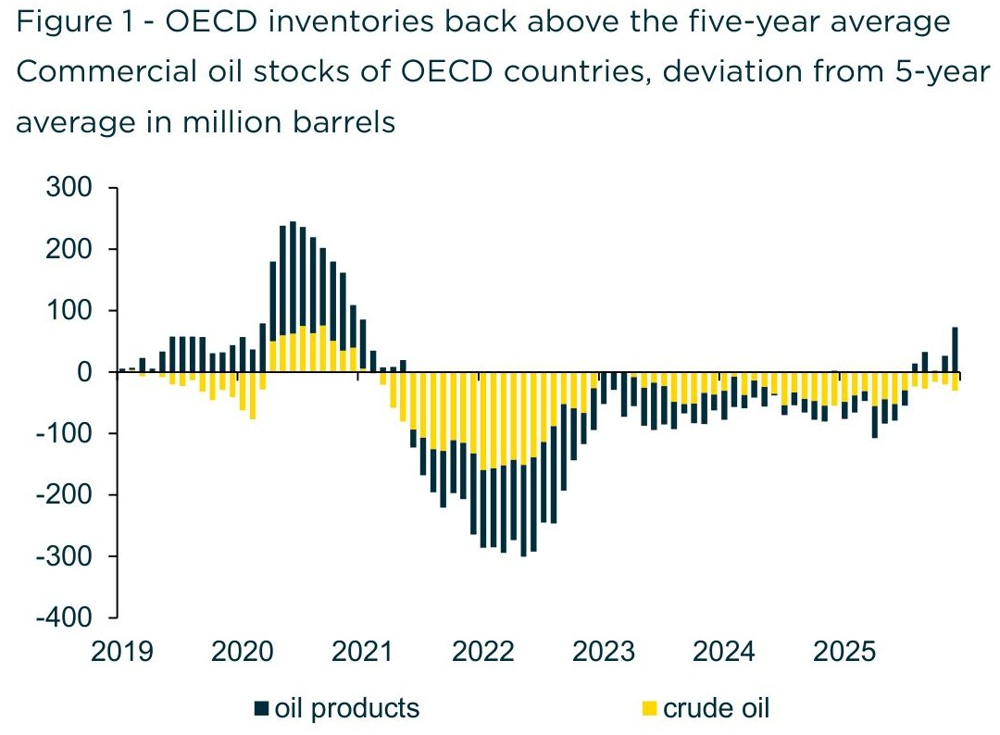

- Cordros Capital Limited adds that non-OPEC+ producers are driving the vast majority of this excess supply, with Brazil and Guyana consistently adding deepwater volumes alongside steady Canadian expansion. ^{[174]}174 • Cordros Capital Limited
US Shale Production Growth Trajectory
While US shale output remains at record highs, brokers flag emerging signs of exhaustion and price-driven constraints, marking a significant divergence from the aggressive growth narratives historically promoted by independent operators.
- Maybank Investment Banking Group identifies a massive structural decoupling in the US shale patch, noting that operators have pushed production to a record 14 mb/d despite operating a recessionary-level rig count of approximately 400. ^{[175]} The broker views this as a peak in operational efficiency driven by longer laterals and simul-frac technology, suggesting further upside is highly constrained. ^{[176]}175 176 • Maybank Investment Banking Group
- Thanachart Securities argues that US supply is no longer a reliable growth driver, as output growth in the Lower 48 dropped to its weakest pace since the COVID-19 pandemic in late 2025. ^{[177]} The firm points out that new shale wells generally require $62.50 per barrel to be profitable, meaning the current low-price environment will forcibly curtail future drilling. ^{[178]}177 178 • Thanachart Securities
- Ambit Capital directly links the impending slowdown in US shale to geological limits, stating that post-COVID efficiency gains have run their course and production growth will slow in 2026 as top-tier acreage is fully depleted. ^{[179]}179 • Ambit Capital
- Huatai Research provides evidence of this fatigue, observing that drilled-but-uncompleted (DUC) well inventories have fallen sharply, indicating that recent production growth relied heavily on drawing down existing inventory rather than new exploration. ^{[180]}180 • Huatai Research
OPEC+ Compliance and Spare Capacity
Analysts view OPEC+ as trapped between defending a price floor and bleeding market share to the Americas, though the cartel holds an unprecedented volume of spare capacity.
- ICBC International Research notes that OPEC+ is struggling to strike a balance between regaining market share and stabilizing retreating prices. ^{[181]} The broker observes that the alliance was forced to suspend its planned production ramp-ups to prevent a total price collapse. ^{[182]}181 182 • ICBC International Research
- Kenanga Research estimates that OPEC+ currently holds a massive 5 mb/d of spare capacity. ^{[183]} The firm notes this is significantly higher than historical crisis periods, providing a substantial physical buffer against severe geopolitical supply shocks. ^{[184]}183 184 • Kenanga Research
- XP Investments offers a slightly more conservative estimate, placing OPEC's immediate spare capacity at roughly 3.5 mb/d. ^{[185]} The broker emphasizes that this idle capacity makes the long-term impact of isolated geopolitical outages much less problematic for global balances. ^{[186]}185 186 • XP Investments
Analyst Consensus, Divergences, and Emerging Signals
The overarching consensus confirms a bearish, oversupplied market for 2026, but the intelligence flags deep disagreements regarding the exact scale of the glut and the true state of global demand.
- Czech National Bank highlights a severe lack of consensus among the world's most reputable energy agencies, pointing out that OPEC and the IEA have issued sharply conflicting forecasts. ^{[187]} The bank notes that while OPEC projects demand growth of 1.4 mb/d in 2026, the IEA is highly pessimistic at just 0.7 mb/d, creating an unusually wide margin of error for institutional investors attempting to model the market balance. ^{[188]}187 188 • Czech National Bank
- Intesa Sanpaolo directly challenges the broader bearish consensus, arguing that the IEA's forecast of a 3.8 mb/d surplus in 2026 is excessively pessimistic. ^{[189]} The broker predicts a much smaller surplus of 1.5 mb/d, citing stronger-than-expected resilience in global fuel demand and overly aggressive estimates of non-OPEC+ supply growth. ^{[190]}189 190 • Intesa Sanpaolo
- Emerging Signal: A notable divergence exists between the public confidence of US shale executives regarding sustained inventory and the analyst community's focus on geological limits. While operators consistently report lowering costs, broker research confirms that the systematic draining of DUC wells and the exhaustion of Tier 1 acreage represent hard physical ceilings that will fundamentally halt US shale expansion by 2026. ^{[191]}191 • Huatai Research
Citations
[1] [2] [3] [23] [23] 10K • Exxon Mobil Corp • 18 Feb 26 • "Annual Report FY 2025"
[4] [25] [34] Transcript - Earnings Calls • Chevron Corp • 30 Jan 26 • "Q4 2025 Earnings Call"
[5] [6] INTRM • Chevron Corp • 30 Jan 26 • "Chevron Reports Fourth Quarter 2025 Results"
[7] [8] [17] [29] Transcript - Earnings Calls • TotalEnergies SE • 11 Feb 26 • "Q4 2025 Earnings Call"
[9] [10] Freedom Broker • Shell PLC • 06 Feb 26 • "SHEL: Shell (SHEL) Q4 2025 Results; Growth Potential Limited"
[11] [13] [15] [30] [31] ARS • BP PLC • 10 Feb 26 • "4Q25 SEA Part 1 of 1"
[12] [37] ARS • BP PLC • 10 Feb 26 • "Fourth quarter and full year 2025"
[14] INTRM • BP PLC • 10 Feb 26 • "4Q25 SEA Part 1 of 1"
[16] Freedom Broker • TotalEnergies SE • 13 Feb 26 • "TTE: TotalEnergies (TTE) Q4 2025 Results; Recommendation Lowered to Sell"
[18] [19] [20] [35] [36] Transcript - Earnings Calls • Shell PLC • 05 Feb 26 • "Q4 2025 Earnings Call"
[21] [27] 8K • Exxon Mobil Corp • 30 Jan 26 • "Results of Operations and Financial Condition ; Regulation FD Disclosure"
[22] Transcript - Earnings Calls • Exxon Mobil Corp • 30 Jan 26 • "Q4 2025 Earnings Call"
[26] Transcript - Earnings Calls • Exxon Mobil Corp • 02 May 25 • "Q1 2025 Earnings Call"
[28] Transcript - Earnings Calls • Chevron Corp • 31 Oct 25 • "Q3 2025 Earnings Call"
[32] Transcript - Earnings Calls • Exxon Mobil Corp • 31 Oct 25 • "Q3 2025 Earnings Call"
[33] [38] Freedom Broker • Exxon Mobil Corp • 03 Feb 26 • "XOM: ExxonMobil (XOM) Q4 2025 Results; Sell Reaffirmed"
[39] [40] Freedom Broker • Chevron Corp • 02 Feb 26 • "CVX: Chevron (CVX) Q4 2025 Results; "Sell" Reiterated"
[41] Freedom Broker • BP PLC • 12 Feb 26 • "BP: BP (BP) Q4 2025 Results; Recommendation Downgraded to Sell"
[42] [43] Edison Investment Research • BP PLC • 11 Feb 26 • "bp:Q425 results: In line, balance sheet strengthening"
[44] [45] [46] Hannam & Partners • 16 Feb 26 • "Oil and Gas: Oil Majors’ need for resource replenishment presents opportunities for E&P companies"
[47] Transcript - Earnings Calls • Saudi Arabian Oil Co • 05 Aug 25 • "Q2 2025 Earnings Call"
[48] [50] [61] Transcript - Earnings Calls • Saudi Arabian Oil Co • 10 Mar 26 • "Q4 2025 Earnings Call"
[49] Transcript - Earnings Calls • Saudi Arabian Oil Co • 04 Nov 25 • "Q3 2025 Earnings Call"
[51] Oxford Business Group • 08 Feb 26 • "The report Saudi Arabia 2025"
[52] Earnings Presentation • Saudi Arabian Oil Co • 10 Mar 26 • "Saudi Arabian Oil Company – 2025 Q4 Presentation"
[53] [54] [55] [56] [60] ARS • Saudi Arabian Oil Co • 10 Mar 26 • "Annual Report"
[57] [58] [62] [63] [64] [65] [67] [68] ARS • Saudi Arabian Oil Co • 10 Mar 26 • "Aramco announces fourth quarter and full-year 2025 results"
[59] Transcript - Earnings Calls • Saudi Arabian Oil Co • 04 Mar 25 • "Q4 2024 Earnings Call"
[66] PROSP • Saudi Arabian Oil Co • 27 May 25 • "Saudi Aramco - GMTN Base Prospectus - 27 May 2025(155887519.2)"
[69] [70] [71] QNB Financial Services • 02 Mar 26 • "Daily Market Report"
[72] [73] FAB Securities • 06 Mar 26 • "Geopolitical Conflict to Trigger Market Volatility and Safe-Haven Flows"
[74] SP Angel • 10 Mar 26 • "Morning Energiser : Oil slumps on talk of early end to Iran conflict"
[75] [81] [82] [111] [112] 8K • Diamondback Energy Inc • 23 Feb 26 • "Results of Operations and Financial Condition ; Financial Statements and Exhibits"
[76] [96] Transcript - Earnings Calls • EOG Resources Inc • 08 Nov 24 • "Q3 2024 Earnings Call"
[77] [79] INTRM • Diamondback Energy Inc • 23 Feb 26 • "Diamondback Energy, Inc. Announces Fourth Quarter and Full Year 2025 Financial and Operating Results; Increases Base Dividend"
[78] 8K • Diamondback Energy Inc • 03 Nov 25 • "Results of Operations and Financial Condition ; Financial Statements and Exhibits"
[80] Transcript - Earnings Calls • Diamondback Energy Inc • 06 Aug 24 • "Q2 2024 Earnings Call"
[83] [84] 10Q • Diamondback Energy Inc • 05 Nov 25 • "Quarterly Report Q3 2025"
[85] [88] [89] Transcript - Earnings Calls • Devon Energy Corp • 06 Nov 25 • "Q3 2025 Earnings Call"
[86] Transcript - Earnings Calls • Devon Energy Corp • 02 May 24 • "Q1 2024 Earnings Call"
[87] [87] [91] ARS • Devon Energy Corp • 18 Feb 26 • "MDA"
[92] 10Q • Devon Energy Corp • 06 Nov 24 • "Quarterly Report Q3 2024"
[93] [95] Transcript - Earnings Calls • EOG Resources Inc • 23 Feb 24 • "Q4 2023 Earnings Call"
[94] Press Release • EOG Resources Inc • 24 Feb 26 • "EOG Resources Reports Fourth Quarter and Full-Year 2025 Results; Announces 2026 Capital Plan"
[97] [98] 10Q • EOG Resources Inc • 07 Aug 25 • "Quarterly Report Q2 2025"
[99] [101] Transcript - Earnings Calls • Occidental Petroleum Corp • 19 Feb 26 • "Q4 2025 Earnings Call"
[100] Transcript - Earnings Calls • Occidental Petroleum Corp • 11 Nov 25 • "Q3 2025 Earnings Call"
[102] [103] 10K • Occidental Petroleum Corp • 18 Feb 25 • "Annual Report FY 2024"
[104] [106] [107] 10K • Exxon Mobil Corp • 19 Feb 25 • "Annual Report FY 2024"
[105] Transcript - Earnings Calls • Pioneer Natural Resources Co • 27 Apr 23 • "Q1 2023 Earnings Call"
[108] [109] Streetwise Reports • 04 Feb 26 • "The Crude Chronicles: Navigating the Permian's Peak"
[110] Freedom Broker • EOG Resources Inc • 12 Nov 25 • "EOG: EOG Resources (EOG) Q3 2025 Results"
[113] [114] Expert Call • Glencore PLC • 01 Jun 22 • "Former Competitor Believes Commodity Traders Like GLNCY Will Continue to Generate Profits Due to Persistent Demand for Core Commodities"
[115] [116] Expert Call • Glencore PLC • 15 May 25 • "Former Competitor Sees Further Consolidation Ahead For the Mining Industry"
[117] Freedom Broker • Glencore PLC • 29 Jan 26 • "GLNCY: Strategic Re-Weighting and Guidance Consistency"
[118] Freedom Broker • Glencore PLC • 23 Feb 26 • "GLEN: Transformation defined by a successful pivot to Cu-led growth and a powerful H2 operational rebound"
[119] Vunani Securities • 03 Feb 26 • "January 2026: Global & Local JSE Equities, SA Bonds and Resources"
[120] [121] SMIFS • 09 Jan 26 • "Indian market outlook and global news and views 09-01-2026"
[122] Systematix Institutional Research • 30 Oct 25 • "Morning Brew"
[123] Shajar Capital • 04 Aug 25 • "TREC Holder: Pakistan Stock Exchange Limited : SHAJAR CAPITAL PAKISTAN (PVT) LIMITED"
[124] [125] SP Angel • 07 Nov 25 • "Morning Energiser : Gunvor withdraws bid for Lukoil International"
[126] [127] SMIFS • 02 Dec 25 • "Indian market outlook and global news and views 02-12-2025"
[128] Ubhar Capital • 01 Dec 25 • "U Capital - Pre-Market December 01 ,2025"
[129] [130] [132] [133] WIIW • 20 Feb 26 • "Economic implications for Europe of a potential reintegration of Iran into the world economy"
[131] Commerzbank • 24 Feb 26 • "Additional uncertainty following US tariff ruling"
[134] [135] [179] Ambit Capital • Reliance Industries Ltd • 27 Feb 26 • "Value-accretive energy security tilt"
[136] [137] [138] CD Equisearch • 31 Dec 25 • "Report- Russia on tenterhooks"
[139] [140] Systematix Institutional Research • 09 Jan 26 • "Morning Brew"
[141] [142] Kiwoom Sekuritas • 10 Dec 25 • "Morning Equity"
[143] BIMB Securities • 02 Mar 26 • "Thematic: US-Iran Conflict : The Hormuz Hedge: Navigating Malaysia’s Markets Amid Middle East Turmoil"
[144] [146] [147] QNB Financial Services • 10 Mar 26 • "Daily Market Report"
[145] QNB Financial Services • 08 Mar 26 • "Daily Market Report"
[148] ING Wholesale Banking • 05 Mar 26 • "ING Monthly: War in the Middle East takes hold of the global economy"
[149] [150] Kiwoom Sekuritas • 10 Mar 26 • "Morning Equity"
[151] [152] Expert Call • SLB Ltd • 03 Dec 25 • "VP at Weatherford International Sees Growth in Offshore Drilling and Emphasizes Technology's Role in Energy Sector"
[153] [154] [183] [184] Kenanga Research • 09 Mar 26 • "Sector Update : Oil & Gas : History Never Repeats, But it Rhymes"
[155] [156] [157] [156] Desjardins Economics studies • 04 Mar 26 • "ECONOMIC VIEWPOINT : Economic and Oil Market Implications"
[159] [160] [161] Zedcrest Wealth • 02 Mar 26 • "Oil & Gas update | The Iran shock, oil risk premium expansion, and the inflation resurgence cycle"
[162] OPEC • 14 Jan 26 • "OPEC Monthly Oil Market Report"
[163] OPEC • 11 Dec 25 • "OPEC Monthly Oil Market Report"
[164] [165] Kamco • 17 Feb 26 • "Oil Market Monthly Report-Feb-2026: Oil prices remain steady at elevated levels led by geopolitics"
[166] [167] [181] [182] ICBC International Research • 24 Nov 25 • "ICBCI - Global Economic Outlook and Investment Strategy 2026"
[168] Meristem Securities • 31 Dec 25 • "Meristem 2026 Full Year Outlook - Stability to Strength: Panning Gems on Firmer Grounds"
[169] [170] MBC Group • 20 Jan 26 • "Consolidation of reforms; New opportunities, New Dividends"
[171] U.S. Energy Information Administration • 11 Feb 26 • "Short-Term Energy Outlook : STEO February 2026"
[172] [172] Commerzbank • 03 Mar 26 • "Escalation in the Middle East drives up energy prices"
[174] Cordros Capital Limited • 11 Dec 25 • "2026 Outlook | Building Momentum Beyond the Rebound | Macros and Market Review & Outlook"
[175] [176] Maybank Investment Banking Group • 10 Dec 25 • "Macro research - 2026 Year Ahead: Policy-driven growth"
[177] [178] Thanachart Securities • PTT Exploration & Production PCL • 19 Feb 26 • "PTTExp : Sustainable yields"
[180] [191] Huatai Research • 19 Jan 26 • "【Huatai Research】Basic Chemicals/Oil & Gas — New Cycle Takes Shape, New Domains Proliferate"
[185] [186] XP Investments • Petroleo Brasileiro SA Petrobras • 02 Mar 26 • "Brazil Oil & Gas | A Pandora Box has been opened – US-Iran conflict"
[187] [188] Czech National Bank • 06 Jan 26 • "GLOBAL ECONOMIC OUTLOOK : OCTOBER 2025"
[189] [190] Intesa Sanpaolo • 19 Dec 25 • "Intesa Sanpaolo S.p.A. - Macroeconomic Outlook - December 2025"

